1. Which of the following costs would be classified as a direct cost for a company that produces motorcycles?
Multiple Choice

- 
Rent of manufacturing facility that produces motorcycles
Seats used in the motorcycles
Wages of motorcycle assembly workers
Both Seats used in the motorcycles and Wages of motorcycle assembly workers are correct.

2. Manufacturing costs that cannot be traced to specific units of product in a cost-effective manner are:
Multiple Choice

depreciation on production equipment.
direct material.
indirect labor.
Both depreciation on production equipment and indirect labor.

3. During its first year of operations, Connor Company paid $50,000 for direct materials and $36,000 in wages for production workers. Lease payments and utilities on the production facilities amounted to $14,000. General, selling, and administrative expenses were $16,000. The company produced 5,000 units and sold 4,000 units for $30.00 a unit. The average cost to produce one unit is which of the following amounts?
Multiple Choice

$20.00
$16.00
$18.40
$25.00

4. Why do accountants normally calculate cost per unit as an average?
Multiple Choice

Determining the exact cost of a product is virtually impossible.
Some manufacturing-related costs cannot be accurately traced to specific units of product.
Even when producing multiple units of the same product, normal variations occur in the amount of materials and labor used.
All of these are justifications for computing average unit costs.

5. During its first year of operations, Silverman Company paid $14,000 for direct materials and $19,000 for production workers' wages. Lease payments and utilities on the production facilities amounted to $17,000 while general, selling, and administrative expenses totaled $8,000. The company produced 5,000 units and sold 3,000 units at a price of $15.00 a unit.
What is the amount of gross margin for the first year?
Multiple Choice

$15,000
$24,000
$20,000
$45,000

6. Which of the following items would not be found on a contribution format income statement?
Multiple Choice

Fixed cost
Variable cost
Gross margin
Net income

7. Based on the following cost data, items labeled (a) and (b) in the table below are which of the following amounts, respectively?
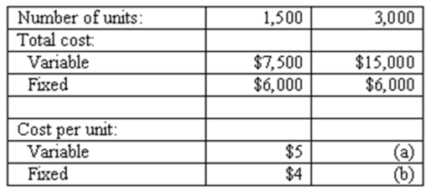

Multiple Choice

(a) = $3.00; (b) = $3.00
(a) = $5.00; (b) = $4.00
(a) = $2.50; (b) = $2.00
(a) = $5.00; (b) = $2.00

8. The following income statement is provided for Grant, Inc.
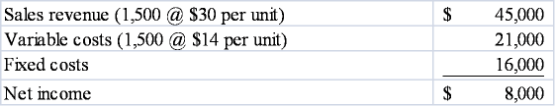
What is this company's magnitude of operating leverage?
Multiple Choice

0.33
1.31
2.00
3.00

9. A cost that contains both fixed and variable elements is referred to as a:
Multiple Choice

mixed cost.
hybrid cost.
relevant cost.
nonvariable cost.

10. Select the correct statement regarding fixed costs.
Multiple Choice

There is a contradiction between the term "fixed cost per unit" and the behavior pattern implied by the term.
Fixed cost per unit is not fixed.
Total fixed cost remains constant when volume changes.
All of these are correct statements.

11. Fixed cost per unit:
Multiple Choice

decreases as production volume decreases.
is not affected by changes in the production volume.
decreases as production volume increases.
increases as production volume increases.

12. Craft, Inc. normally produces between 120,000 and 150,000 units each year. Producing more than 150,000 units alters the company's cost structure. For example, fixed costs increase because more space must be rented, and additional supervisors must be hired. The production range between 120,000 and 150,000 is called the:
Multiple Choice

differential range.
median range.
relevant range.
leverage range.

13. Overhead costs include:
Multiple Choice

Direct and indirect costs.
Indirect costs only.
Direct costs only.
Neither direct nor indirect costs.

14. Craig Manufacturing Company operates its three production departments within a single facility. Each department produces its own products and maintains its own production equipment. Although they share a common facility, each department is overseen by a separate supervisor. Which one of the following costs is a direct cost of each department?
Multiple Choice

Lease payment on facility
Depreciation on the facility
Production supervisor salary
Plant manager salary

15. Great Outdoors Company makes two types of camping tents. Making a standard camping tent requires 4 hours of labor while making a deluxe camping tent requires 10 hours of labor. During the most recent accounting period the company made 2,000 standard camping tents and 500 deluxe camping tents. Indirect manufacturing costs amounted to $52,000 and are allocated based on labor hours. Based on this information:
Multiple Choice

$4 of overhead cost should be allocated to each camping tent regardless of the type of tent made.
$20.80 of overhead cost should be allocated to each camping tent regardless of the type of tent made.
$16 of overhead cost should be assigned to each standard camping tent and $40 of overhead cost should be assigned to each deluxe tent.
None of these answers is correct.

16. Sheddon Industries produces two products. The products' identified costs are as follows:
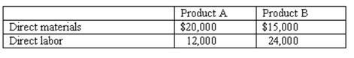
The company's overhead costs of $108,000 are allocated based on direct labor cost. Assume 4,000 units of product A and 5,000 units of Product B are produced. What is the cost per unit for product B? (Do not round your intermediate calculations.)
Multiple Choice

$7.80
$22.20
$16.80
None of these answers is correct.

17 Cash outflows from a capital investment project include:
Multiple Choice

increases in operating expenses.
the reduction in the amount of working capital.
terminal salvage value.
all of these answers are correct.

18. Alleghany Community College operates four departments. The square footage used by each department is shown below.
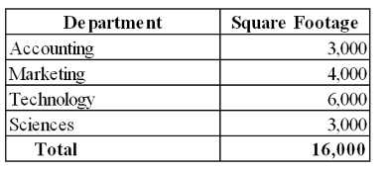
Alleghany's annual building rental cost is $320,000.
What amount of rent expense that should be allocated to the Technology Department?
Multiple Choice

$60,000
$80,000
$120,000
$192,000

19. The Mansfield Company manufactures and sells two lines of fishing rods. During the most recent accounting period, the Pro line and the Novice line sold 15,000 and 2,000 units, respectively. The company's most recent financial statements are shown below:
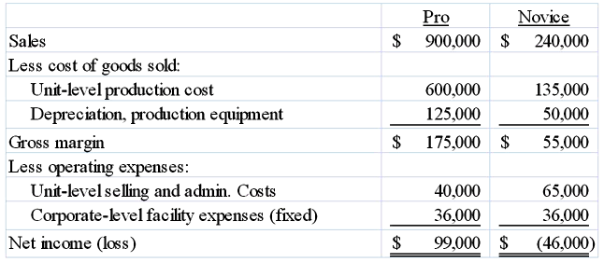
Based on this information, the company should:
Multiple Choice

Eliminate the Novice line because it is operating at a loss.
Keep the Novice line because it contributes $40,000 to total profitability.
Keep the Novice line because it contributes $55,000 to total profitability.
It is impossible to determine with the given information.

20. Outdoor Living Company has just received a special order for 500 hammocks. Outdoor Living has sufficient idle capacity to accept the order. Accepting the order will increase Outdoor Living's variable manufacturing costs. Variable selling and administrative costs would be unaffected. What is the minimum price that Outdoor Living should accept for the special order?
Multiple Choice

A price equivalent to the hammock's variable manufacturing cost per unit
A price equivalent to the hammock's unit contribution margin
The same price that Outdoor Living charges its existing customers
None of these.

21. Pilot Motors Corporation is an automobile manufacturer. The company produces its own motors, tires, and other automobile parts. Pilot has the opportunity to purchase tires from another manufacturer instead of producing them in their own facility. This type of decision is typically known as a(n):
Multiple Choice

outsourcing decision.
special order decision.
segment elimination decision.
asset replacement decision.

22. Clean, Inc. cleans and waxes floors for commercial customers. The company is presently operating at less than capacity with equipment and employees idle at times. The company recently received an order from a potential customer outside the company's normal geographic service region for a price of $4,500. The size of the proposed job is 11,000 square feet. The company's normal service costs are as follows:
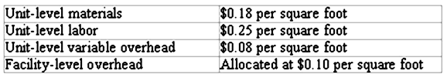
If the company accepts the special offer:
Multiple Choice

The company will lose $1,110 on the job.
The company will lose $2,210 on the job.
The company will lose $230 on the job.

23. Easton Company makes and sells scooters. Easton incurred the following costs in its most recent fiscal year:
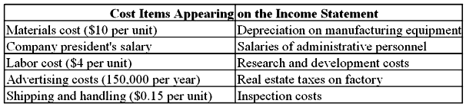
Easton can currently purchase the scooters it makes from another company. If the company purchases the scooters, Easton would still continue to use its own logo, sales staff, and advertising programs. Which of the following costs would be classified as a unit-level cost?
Multiple Choice

Company president's salary
Depreciation on manufacturing equipment
Materials cost
Real estate taxes on factory

24. ServicePro provides two kinds of services. During the most recent accounting period, the two service lines produced the following operating results:
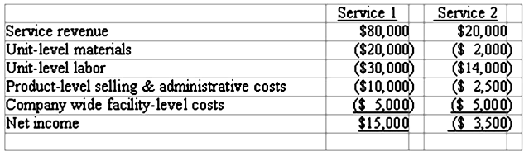
If the company stops providing Service 2:
Multiple Choice

The company's income will decrease by $1,500 per year.
The company's income will increase by $1,500 per year.
The company's income will decrease by $3,500 per year.
The company's income will increase by $3,500 per year.

25. Which of the following items is not needed to prepare an inventory purchases budget for a merchandising business?
Multiple Choice

Expected unit selling price
Beginning inventory
Expected unit sales
Desired ending inventory

26. Which of the following items typically found on the selling and administrative expense budget will also impact the cash budget?
Multiple Choice

Depreciation expense
Administrative salaries
Advertising expense
Both administrative salaries and advertising expense are correct.

27. Which of the following cash budget equations is incorrect?
Multiple Choice

Cash payments + cash receipts = cash requirements
Beginning cash + cash receipts = total cash available
Cash payments + cash cushion = total cash needed
Period one ending cash balance = period two beginning cash balance

28. Sales for January are budgeted at 50,000 units, and the company expects sales to increase 4% each month. How many units will need to be purchased in February if the company's policy is to keep ending inventory each month at 10,000 units?
Multiple Choice

52,000 units
54,000 units
62,000 units
None of these answers is correct.

29. Which of the following items will not appear on a cash budget?
Multiple Choice

Expected cash collections
Expected cash payments
Expected credit sales
Financing activities

30. Oakton Furniture provided the following information relevant to its sales for December 2013 and the first quarter of 2014:
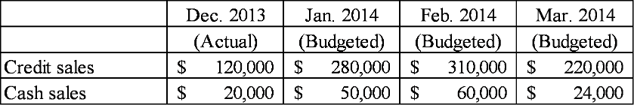
Based on the company's collection history, 2% of credit sales are uncollectible, 40% are collected in month of sale and the remainder collected in the following month. Cash collections in January from December 2013 credit sales would be:
Multiple Choice

$69,600.
$81,200.
$72,000.
$84,000.

31. Scranton Company expects to begin operating on July 1, 2014. The company's master budget contained the following operating expense budget:
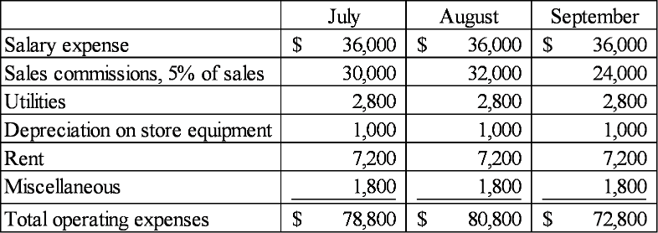
Sales commissions are paid in cash in the month following the month in which the expense is recognized. All other expense items requiring cash payment are paid in the month in which they are recognized. The amount of commissions payable that would appear on the company's September 30, 2014 pro forma balance sheet is:
rev: 11_24_2015_QC_CS-34171
Multiple Choice

$32,000.
$30,000.
$36,000.
$24,000.

32. The total sales variance includes both price and volume variances.
True or False

TrueFalse

33. Flexible budget amounts for costs and revenues come from multiplying standard per unit amounts by the actual volume of production.
True or False

TrueFalse

34. In order to avoid suboptimization, many companies prefer to evaluate their investment centers using
Multiple Choice

Return on investment instead of residual income.
Residual income instead of return on investment.
Gross margin instead of contribution margin.
Sales instead of income.

35. The China's Best Restaurant chain had a 12% return on a $60,000 investment in new ovens. The investment resulted in increased sales, and the resultant increase in income amounted to 4% of the increase in sales. The amount of the increase in sales must have been
Multiple Choice

$7,200.
$60,000.
$180,000.
$500,000.

36. Prater Company made a $100,000 investment in new machinery. Assuming the company's margin is 4%, what income will be earned if the investment generates $300,000 in additional sales?
Multiple Choice

$40,000.
$12,000.
$200,000.
None of these.

37. Which of the following statements is false?
Multiple Choice

Both direct and indirect costs can be assigned to a cost object.
Cost drivers are often selected based on the availability of information.
Volume measures are good drivers for fixed overhead costs.
Fixed costs that do not have a definitive cost driver are allocated using an allocation base that distributes a rational share of the cost to each product.

38. Seth Morrison is considering alternative proposals that involve different amounts of investments. To compare different size investment proposals, it may be helpful for Sarah to prepare a relative ranking of the proposals by using a(n):
Multiple Choice

present value index.
net present value.
internal rate of return.
none of these answers is correct.

39. Which of the following statements concerning payback analysis is true?
Multiple Choice

An investment with a shorter payback is preferable to an investment with a longer payback.
The payback method ignores the time value of money concept.
The payback method and the unadjusted rate of return are different approaches that will not consistently lead to the same conclusion.
All of the other answers are correct.

40. Saget Company is considering the purchase of equipment that would cost $35,000 and offer annual cash inflows of $10,500 over its useful life of 5 years. Assuming a required rate of return of 8%, what is the net present value of this investment opportunity?
Multiple Choice

($6,923)
$17,500
$6,923
$41,923

